1.
Draw and label diagrams of star, bus, and mesh network topologies on paper or using any drawing tool. For each, write one real-world app or service (like WhatsApp, Flipkart, or IPL streaming) that could use that topology and explain why in 1-2 lines.
Star Topology → WhatsApp: Central server manages all messages efficiently.
Bus Topology → Public Wi-Fi in cafes: Simple, low-cost setup.
Mesh Topology → IPL Streaming: Multiple redundant paths ensure uninterrupted streaming.
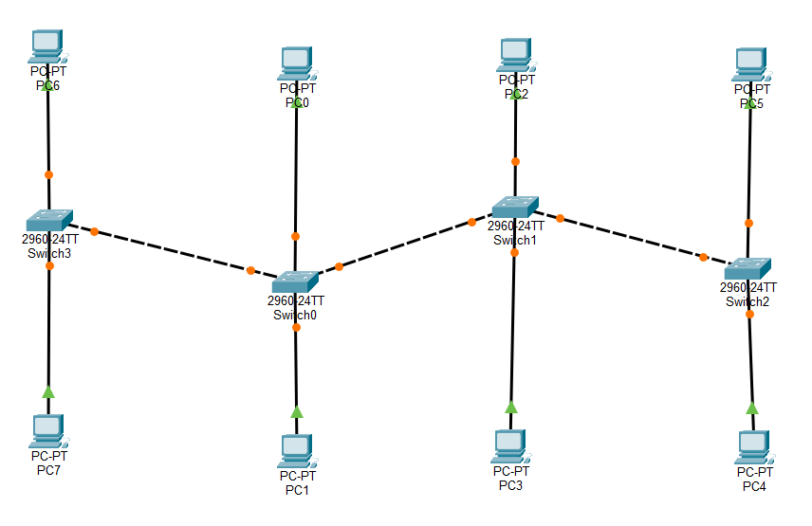BUS TOPOLOGY
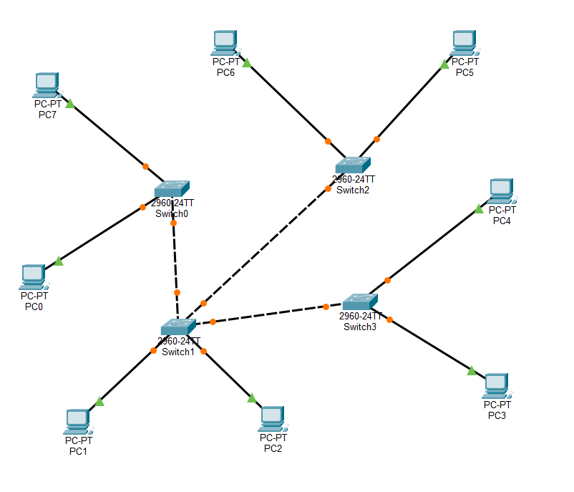MESH TOPOLOGY
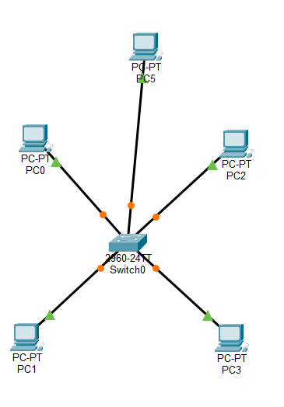STAR TOPOLOGY

2.
Create a comparison table listing at least four pros and four cons for each of these topologies: star, bus, ring, mesh. Include a column for 'Best Use Case' and give an example from apps you use (e.g., Instagram, Zomato, Paytm).
Topology | Pros (4+) | Cons (4+) | Best Use Case (App Example)
Star | Easy to add/remove devices; Fault isolation is simple; Good performance; Reliable if hub strong | Hub failure breaks network; More cabling; Higher cost; Performance depends on hub | Instagram
Bus | Low cost; Easy to set up; Requires less cable; Simple design | Backbone failure stops all; Difficult troubleshooting; Collisions increase with load; Limited scalability | Zomato Wi-Fi in small outlets –
Ring | Predictable data flow; Equal access for devices; Less collisions; Can handle moderate traffic | One device failure disrupts all; Troubleshooting hard; Slower than star; Limited scalability | Paytm
Mesh | High reliability; Multiple paths; Excellent fault tolerance; Scalable for large systems | Very expensive; Complex setup; High cabling; Maintenance heavy | Netflix/Hotstar streaming

3.
Imagine you are designing a new multiplayer mobile game like PUBG or Free Fire. Choose a suitable network topology for the game servers and justify your choice in 3-4 lines, mentioning how it would impact speed, reliability, and cost.
Chosen Topology: Star/Hybrid
Reasoning:
- Speed: Central servers reduce latency for millions of players.
- Reliability: Hybrid design adds backup paths to avoid downtime.
- Cost: Cheaper than full mesh, scalable with cloud infrastructure.

4.
Given this scenario: A small Flipkart-style warehouse wants to connect 8 computers for order processing and inventory updates. Recommend a network topology, sketch a quick diagram, and explain your reasoning in 2-3 lines.<br><br><em><strong>Hint:</strong> Consider factors like cost, ease of troubleshooting, and future expansion.</em>
- Recommended Topology: Star Topology
- Diagram: One central switch/router with 8 PCs connected.
- Reasoning:
  - Cost-effective for small setups.
  - Easy troubleshooting (faults isolated to one link).
  - Future expansion possible by adding more PCs to the hub.

Recommend a network topology, sketch a quick diagram:
